**DATABASE MANAGEMENT SYSTEM**

**MINGGU 4 – REVIEW DEFINING DATA DEFINITION LANGUAGE (DDL)**

NAMA : ISEP LUTPI NUR

NPM : 2113191079

NO ABSEN : 12

KELAS : A2

# **Exercise 1: Creating Tables Using Oracle Application Express**

1. **Create the DDL Statements for creating the tables for the Academic Database listed above – include NOT NULL constraints where necessary. (Other constraints will be added later)**

### **Membuat tabel AD_ACADEMIC_SESSIONS**

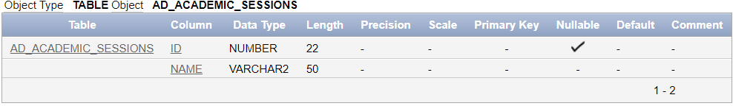

### **Membuat tabel AD_DEPARTMENTS**

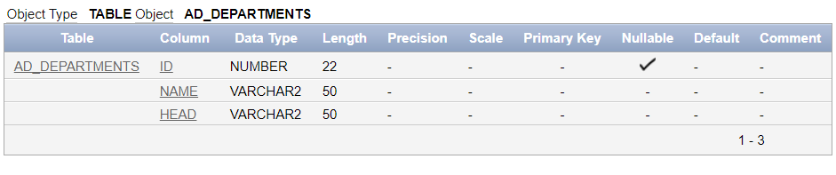

### **Membuat tabel AD_PARENT_INFORMATION**

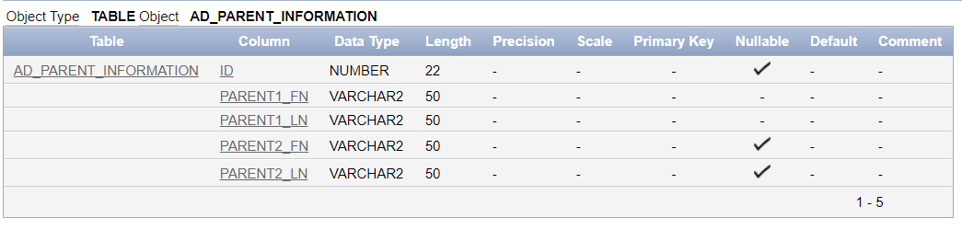

### **Membuat tabel AD_STUDENTS**

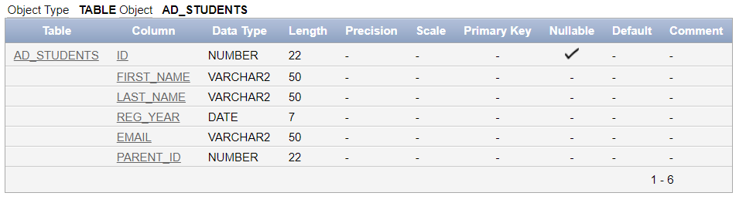

### **Membuat tabel AD_COURSES**

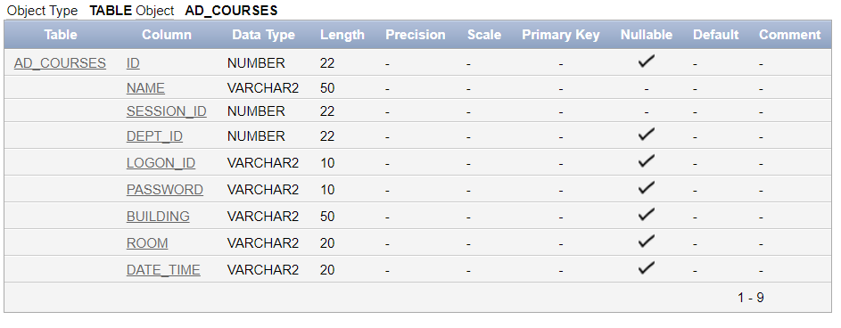

### **Membuat tabel AD_FACULTY**

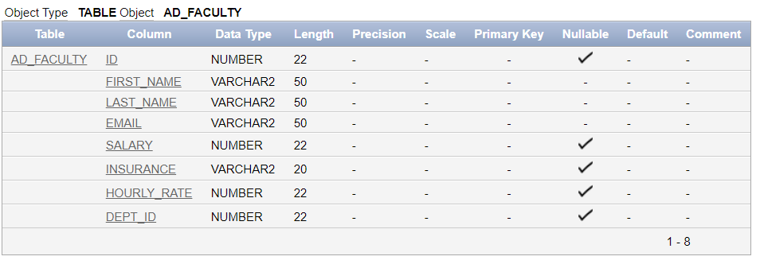

### **Membuat tabel AD_EXAM_TYPES**

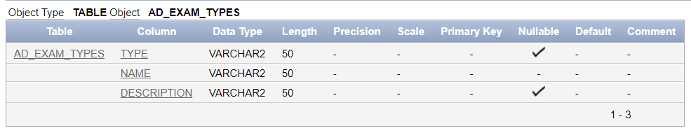

### **Membuat tabel AD_EXAMS**

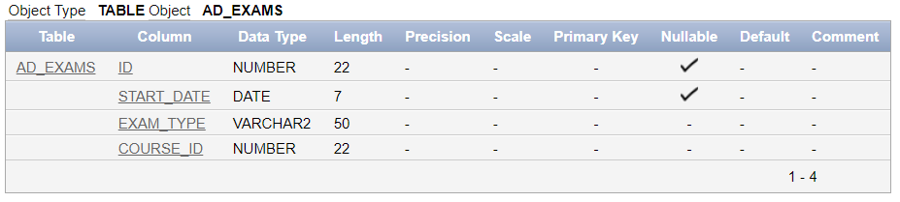

### **Membuat tabel AD_EXAM_RESULTS**

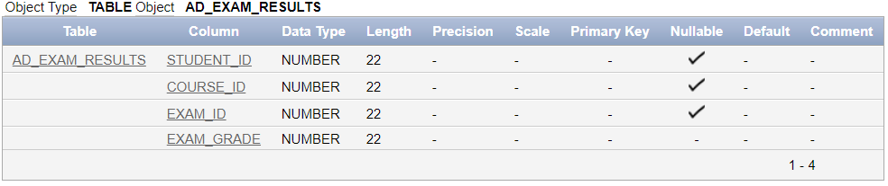

### **Membuat tabel AD_STUDENT_ATTENDANCE**

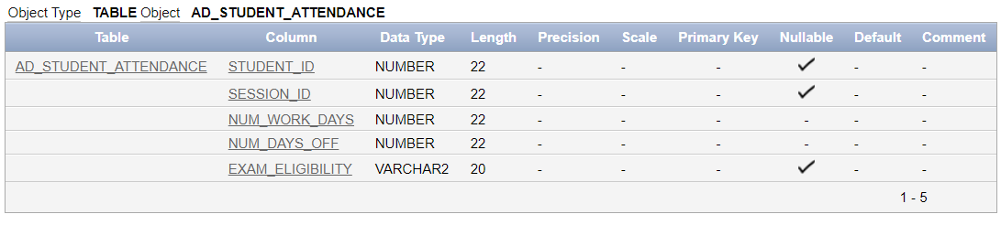

### **Membuat tabel AD_STUDENT_COURSE_DETAILS**

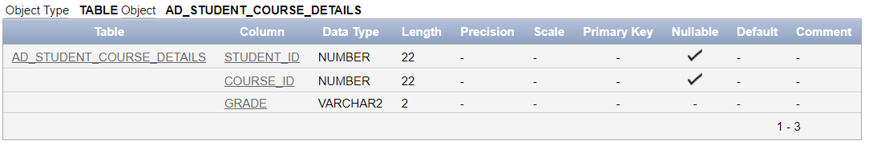

### **Membuat tabel AD_FACULTY_COURSE_DETAILS**

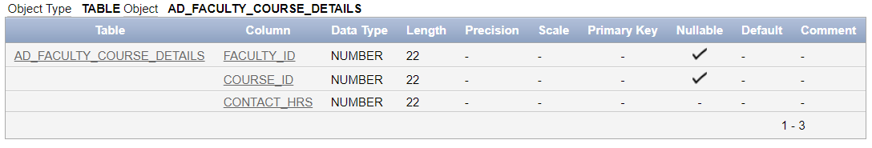

### **Membuat tabel AD_FACULTY_LOGIN_DETAILS**

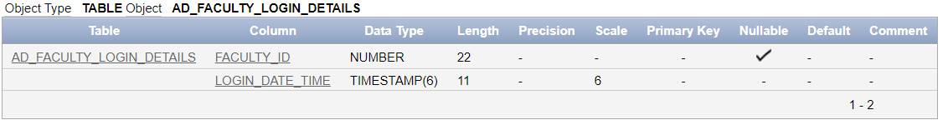

# **Exercise 2: Altering the Tables**

1. **Alter the tables in the Academic Database to define the primary key, foreign key and unique constraints.**

### **Constraint dari table AD_ACADEMIC_SESSIONS**

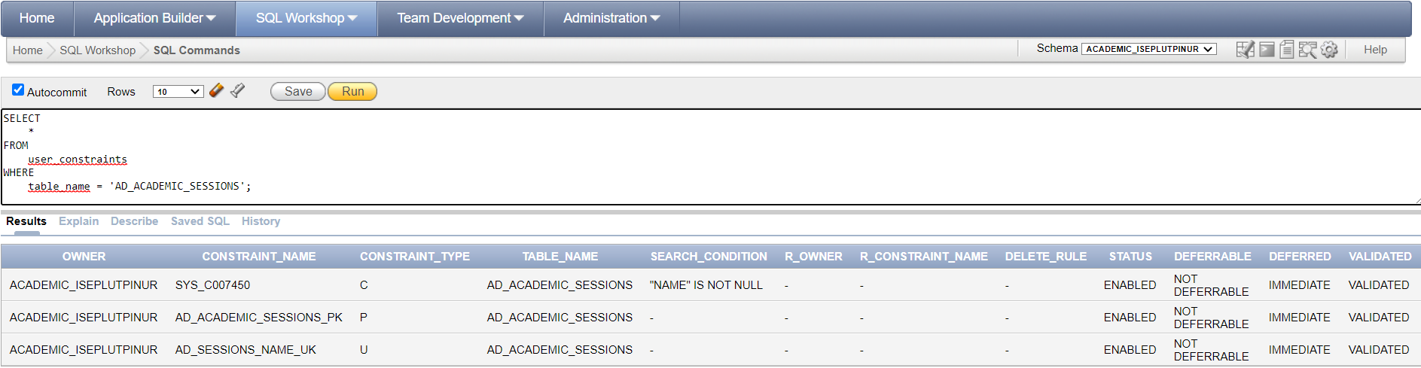

### **Constraint dari table AD_COURSES**

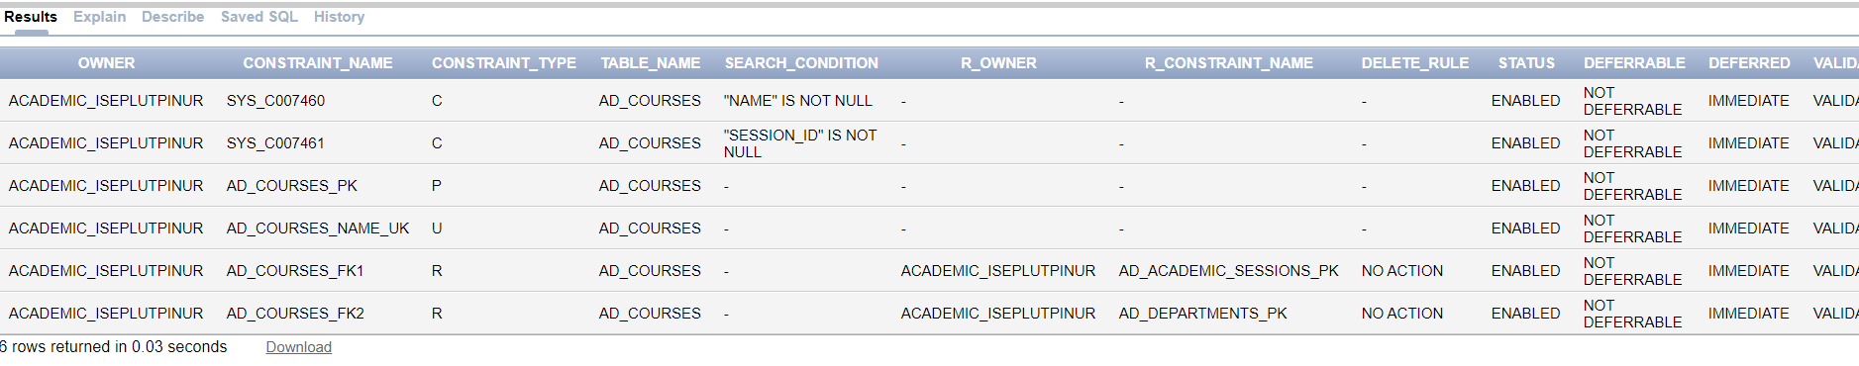

### **Constraint dari table AD_DEPARTMENTS**

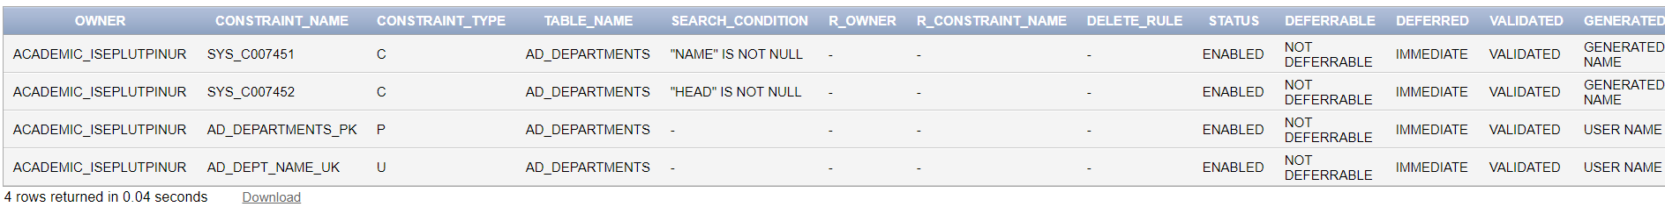

### **Constraint dari table AD_EXAMS**

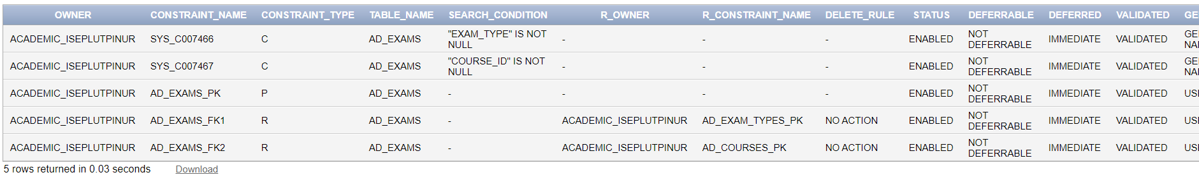

### **Constraint dari table AD_EXAM_TYPES**



### **Constraint dari table AD_EXAM_RESULTS**

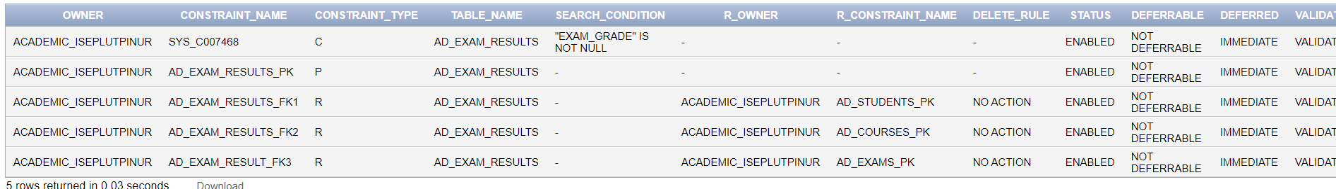

### **Constraint dari table AD_FACULTY**

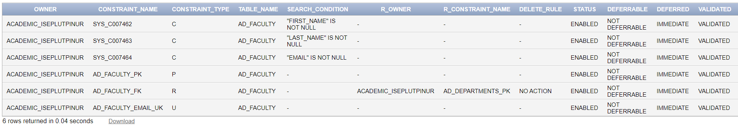

### **Constraint dari table AD_PARENT_INFORMATION**



### **Constraint dari table AD_STUDENTS**

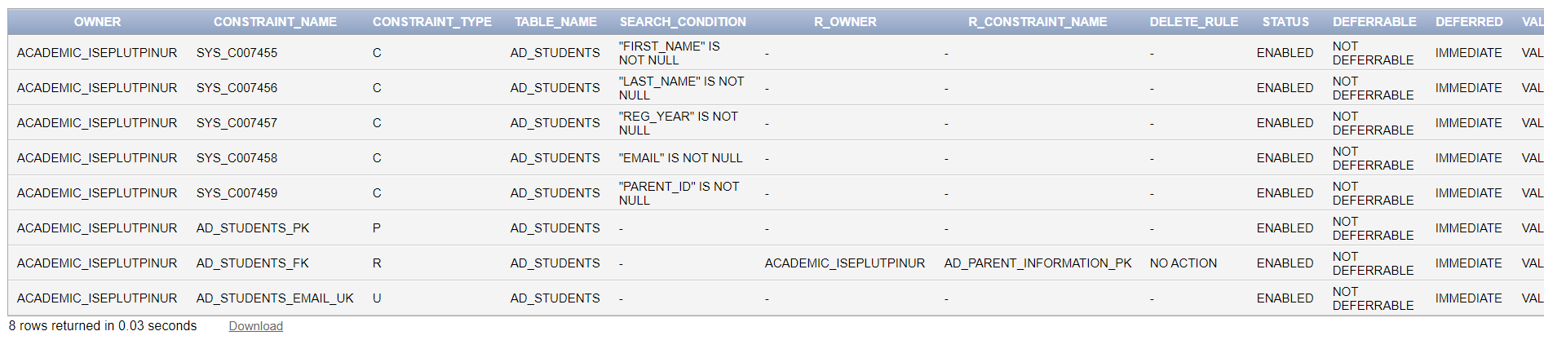

### **Constraint dari table AD_STUDENT_ATTENDANCE**

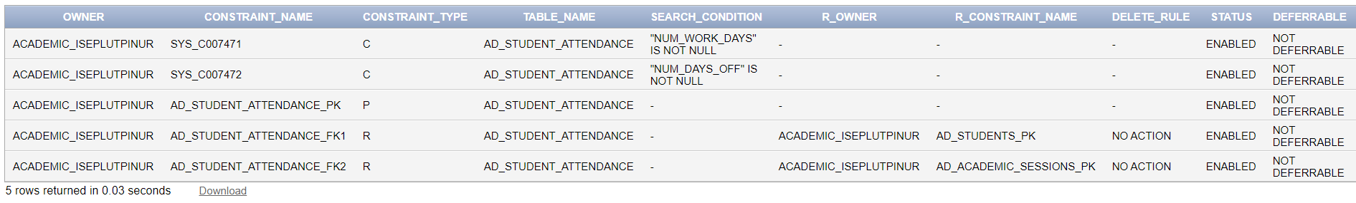

### **Constraint dari table AD_STUDENT_COURSE_DETAILS**

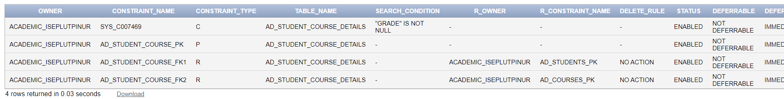

### **Constraint dari table AD_FACULTY_COURSE_DETAILS**

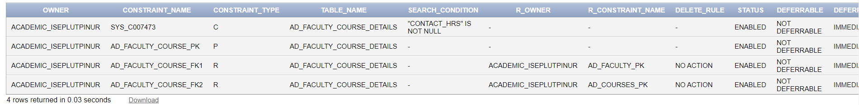

### **Constraint dari table AD_FACULTY_LOGIN_DETAILS**

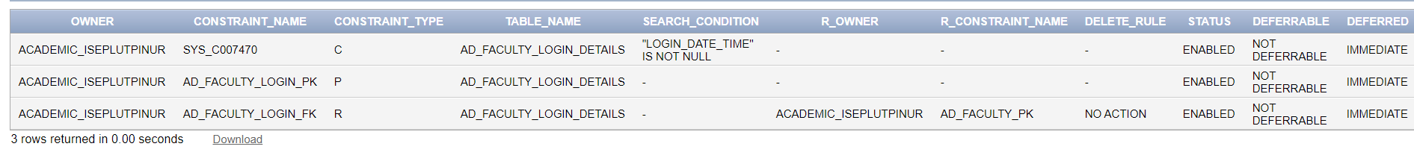

1. **Alter the table AD_FACULTY_LOGIN_DETAILS and specify a default value for the column LOGIN_DATE_TIME of SYSDATE.**

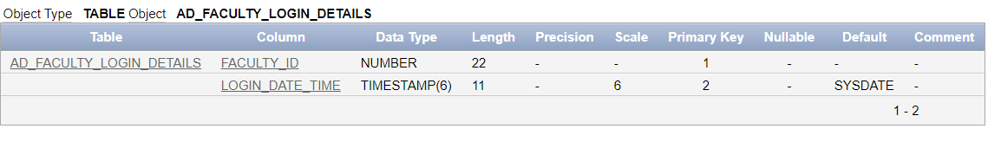

1. **Set the AD_PARENT_INFORMATION table to a read-only status.**

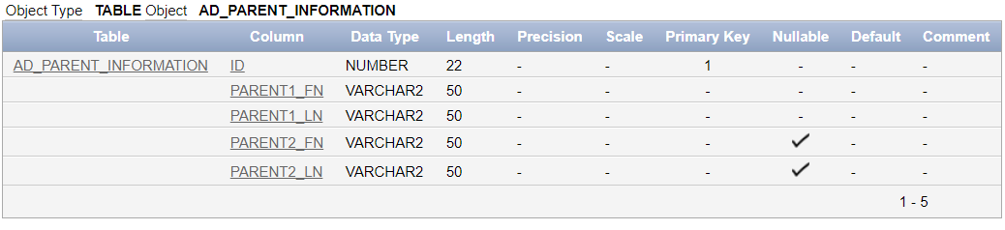

# **Exercise 3: Creating Composite Primary, Foreign and Unique Keys**

## **Create the DEPT table with the following structure:**

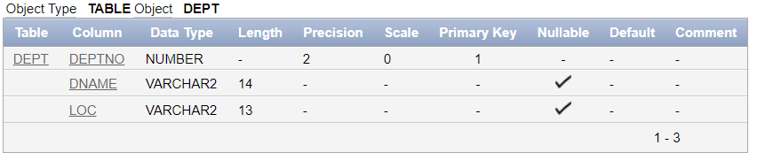

## **Create the SUPPLIERS and PRODUCTS table with the following structure:**

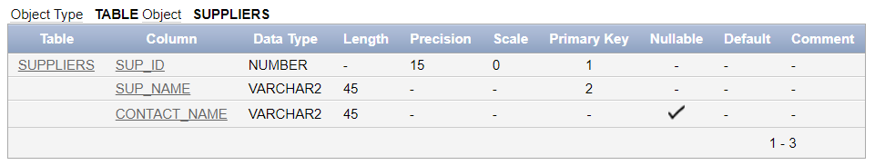

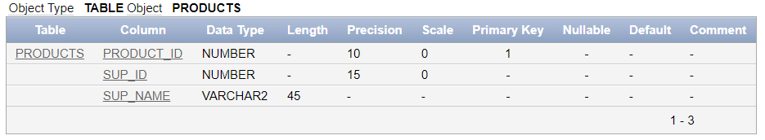

## **Create the DEPT_SAMPLE table with the following structure:**

